|  |
| --- |
| E-Gram Seva |
| Installation Manual v1.0 |
| Team 22 April 10, 2013 |

|  |
| --- |
|  |

**REVISION HISTORY**

|  |  |  |
| --- | --- | --- |
| **Version** | **Author** | **Date** |
| Version 1 | Karan Makim, Siddharth Vadnegra | April 10, 2013 |
| Review Version 1 | Biman Gujral | April 10, 2013 |

**CONTENTS**

**1. Introduction……………………………………………………………………………..4**

**2. How to install the software…………………………………………………………...4**

2.1Installing WAMP……………………………………………………………**4**

2.2Installing Visual Web Ripper……………………………………………...**8**

2.3Installing Diafaan Server………………………………………………….**10**

2.4Installing D-Link connection manager…………………………………...**12**

2.5Setting up codes and saving at appropriate paths……………………..**14**

1. **Configure the software…………………………………………………………………**

3.1 Set-up the databases……………………………………………………**15**

3.2 Configure connections between database and Diafaan…………….**16**

3.3 Configure Windows Task Scheduler…………………………………..**22**

3.4 Set up time for schedules……………………………………………….**24**

**4. System Requirements…………………………………………………………………………………………29**

1. **Introduction**

This document is a stepwise installation guide for installing E-Gram Seva site on server as well on client side.

1. **How to Install the Software**

**2.1 WAMP installation**

2.1.1 Installation of Setup

WAMP (Windows Apache MySQL PHP) will configure the entire three apache server, MySQL database, and PHPmyAdmin on Windows.

You can download the latest version of WAMP server from: <http://sourceforge.net/projects/wampserver/?source=recommended>

Open the installation file as administrator.

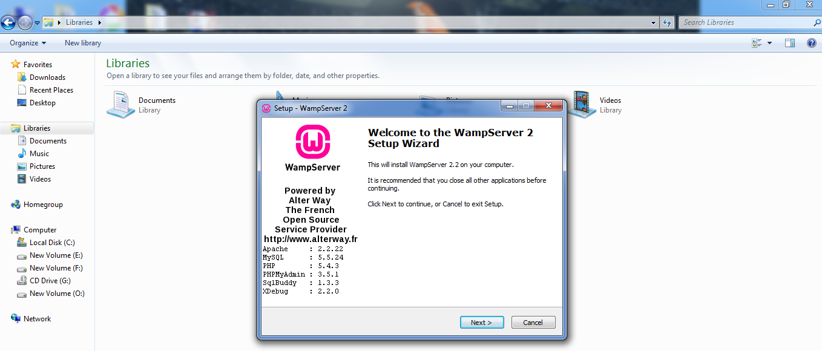

Click on Next

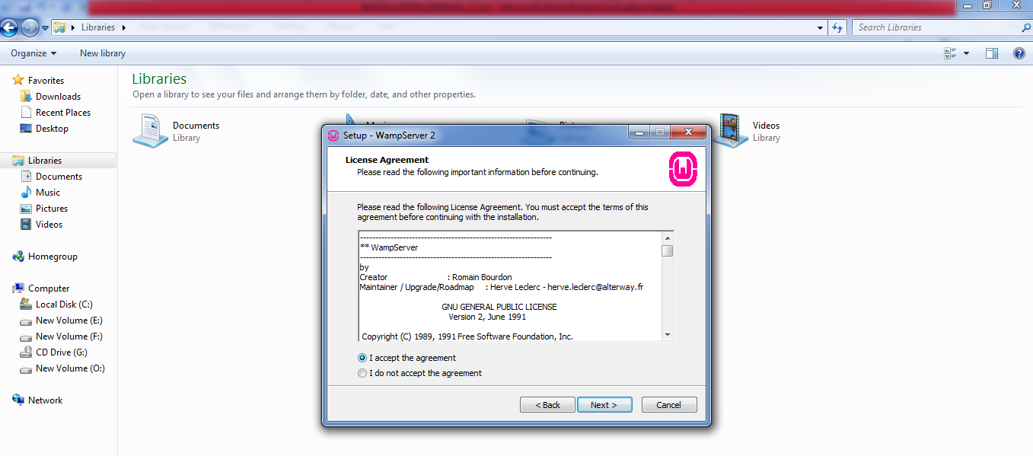

Click on I accept the agreement

Click Next

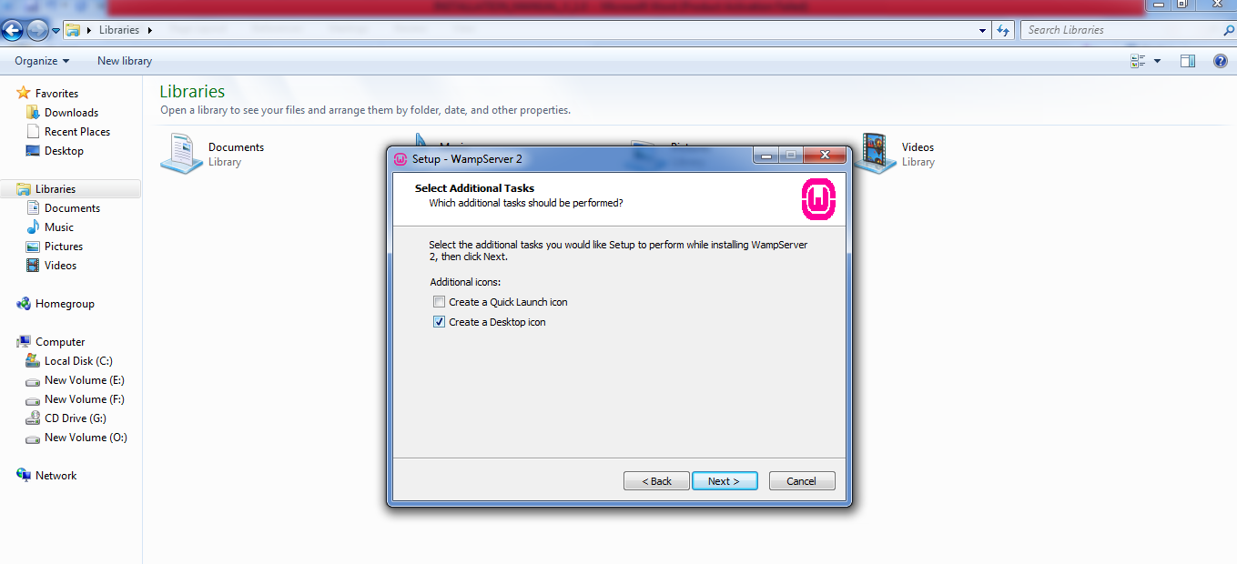

Click on create a Desktop icon.

Click on next.

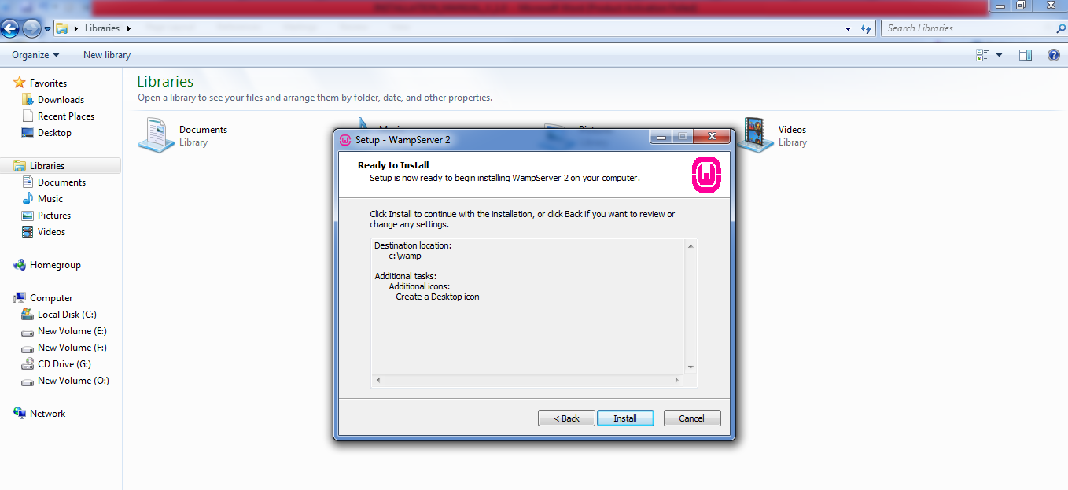

Click on Install

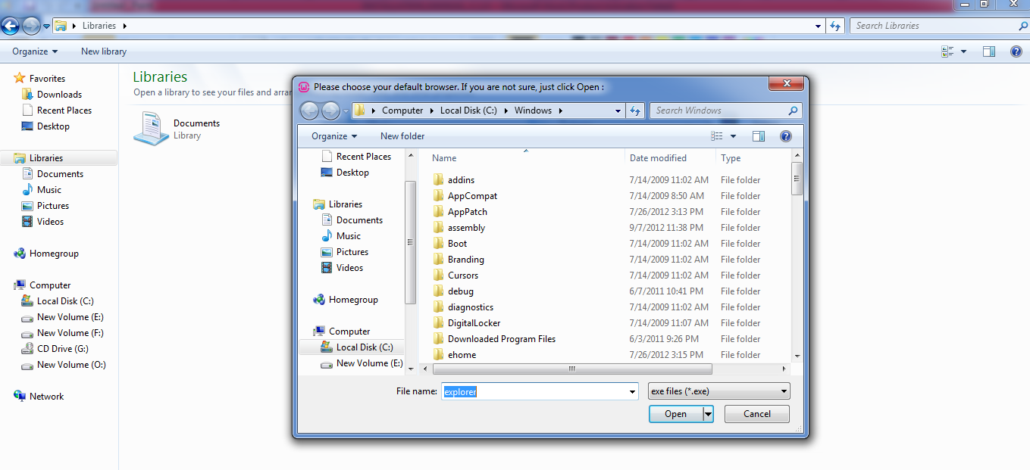

Click your default browser or just select Open

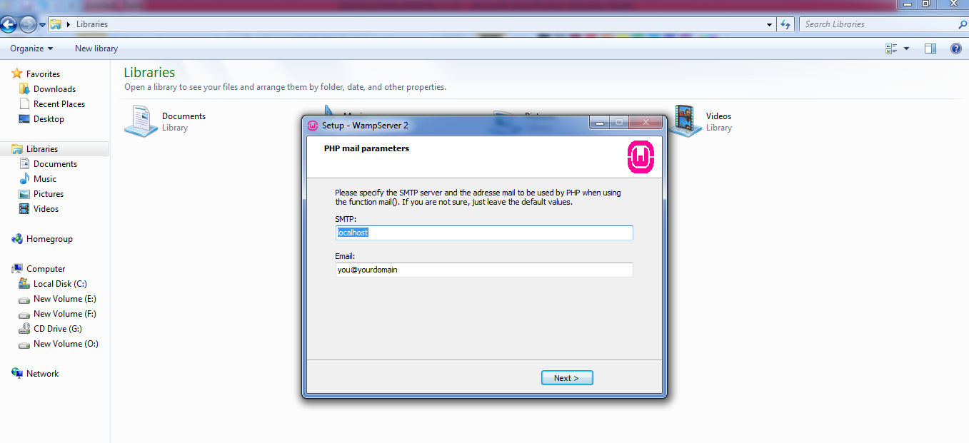

Write your SMTP server and email.

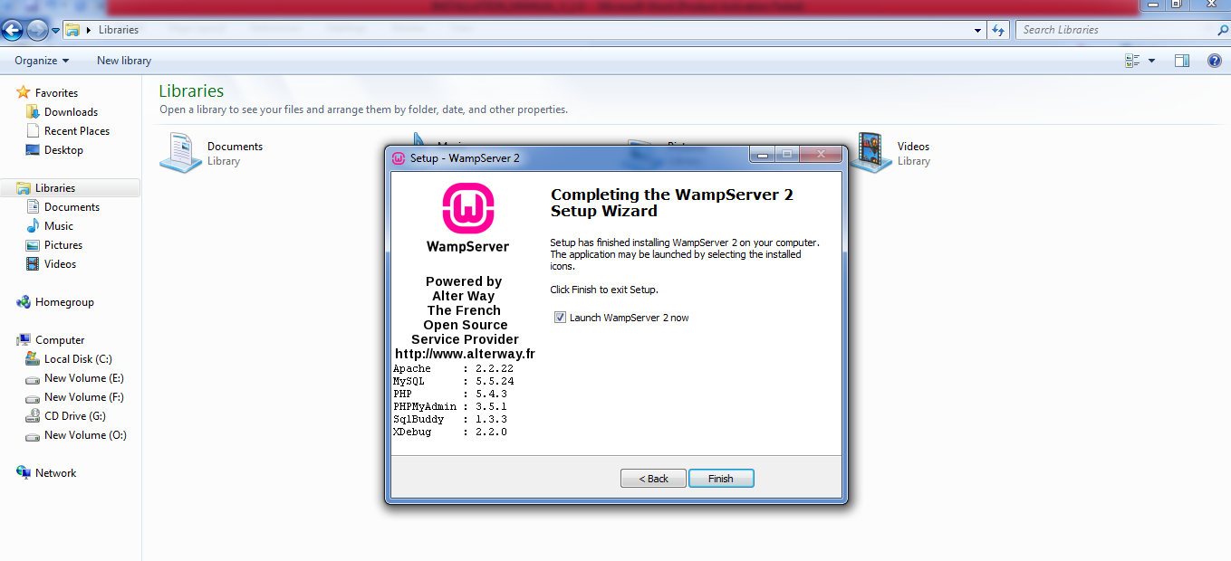

Click on Finish

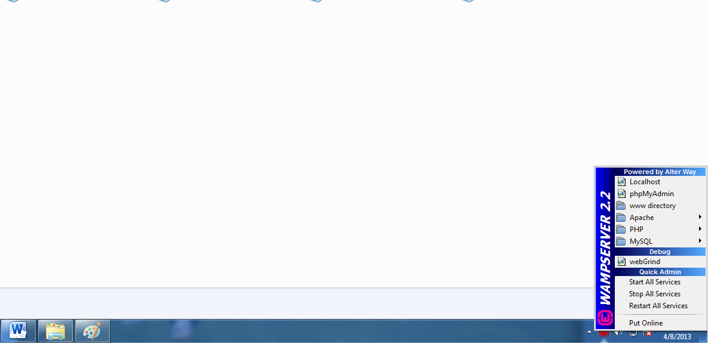

Click on Wamp server in system tray.

Click on start all service.

Click on Put Online.

2.1.2 Configuring the site

* Configuring the site in WAMP

Copy the folder egram_seva at C:\wamp\www\. Open WAMP Control Panel. Click on start apache and start MySQL.

**2.2 Installing Visual Web Ripper**

Run the setup file in the disk.

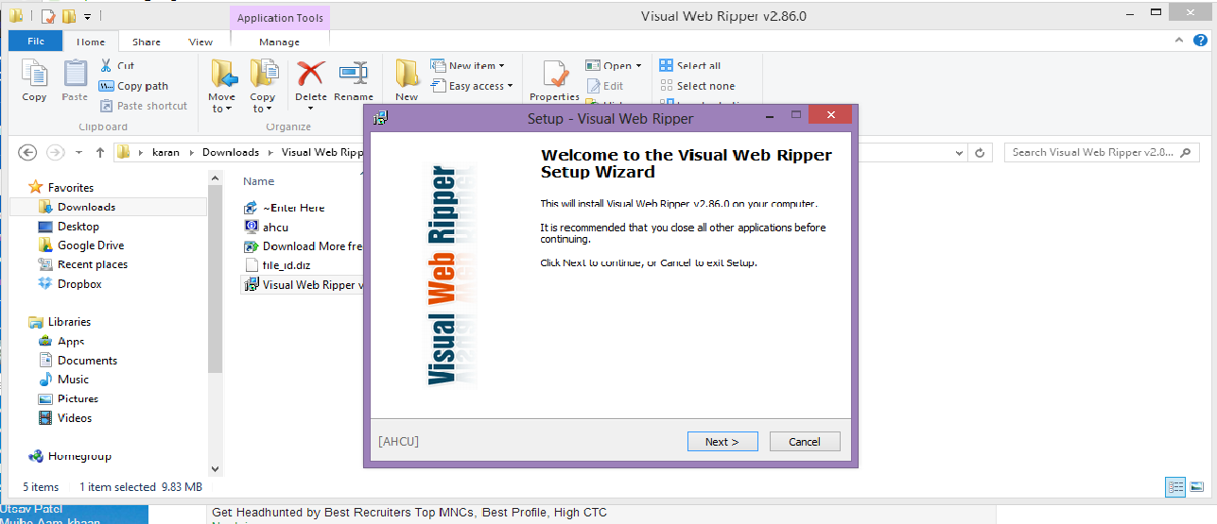

Press Next twice

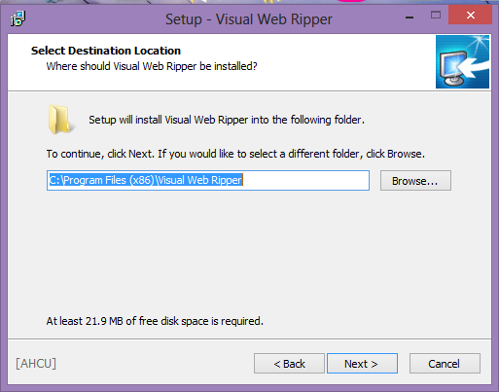

Followed by a ‘Next’ , ‘Install’ and ‘Next’ Clicks, Visual Web ripper is now installed.

**2.3 Installing Diafaan Server**

Run the setup file of Diafaan Server on the disk.

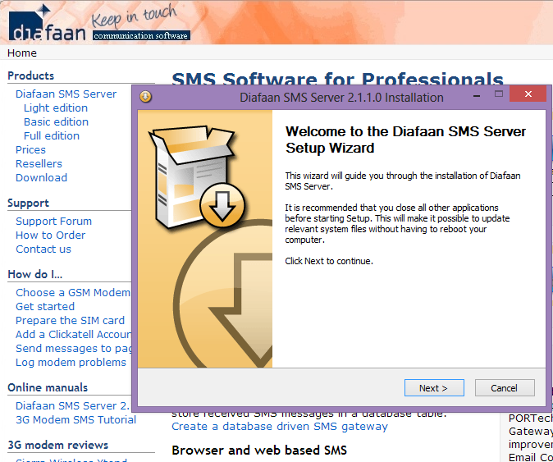

Accept the Terms and conditions

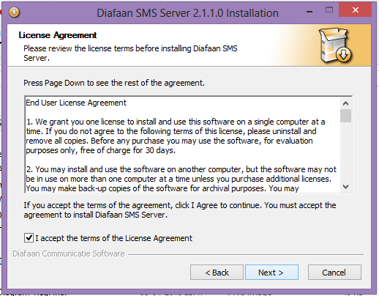

Click Next



Click ‘Next’ followed by ‘Finish’ and Diafaan Server is installed.

**2.4 Installing D-Link connection Manager**

After connecting the modem for the first time, set up D-Link connection manager as follows:

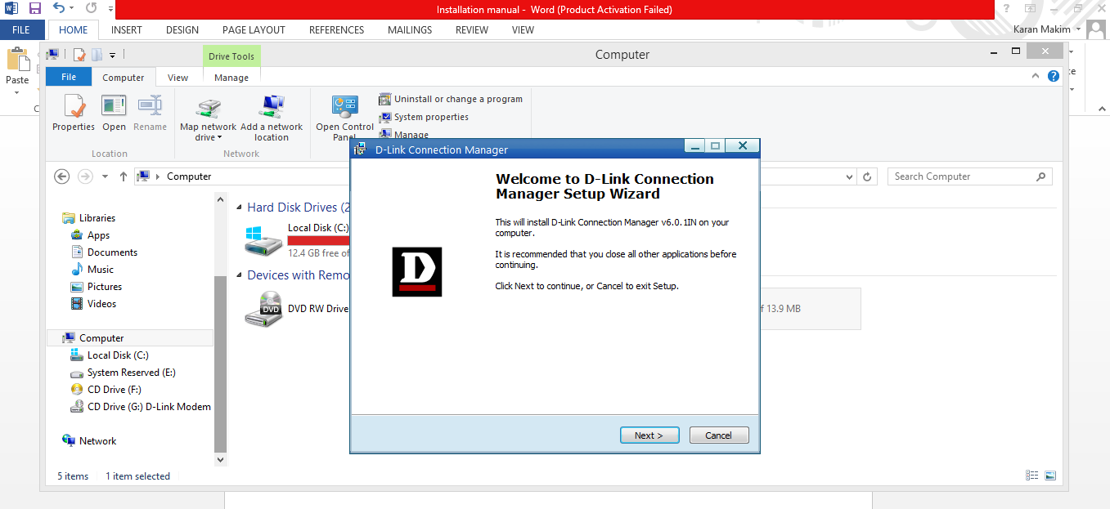

Click Next and you’ll be prompted:

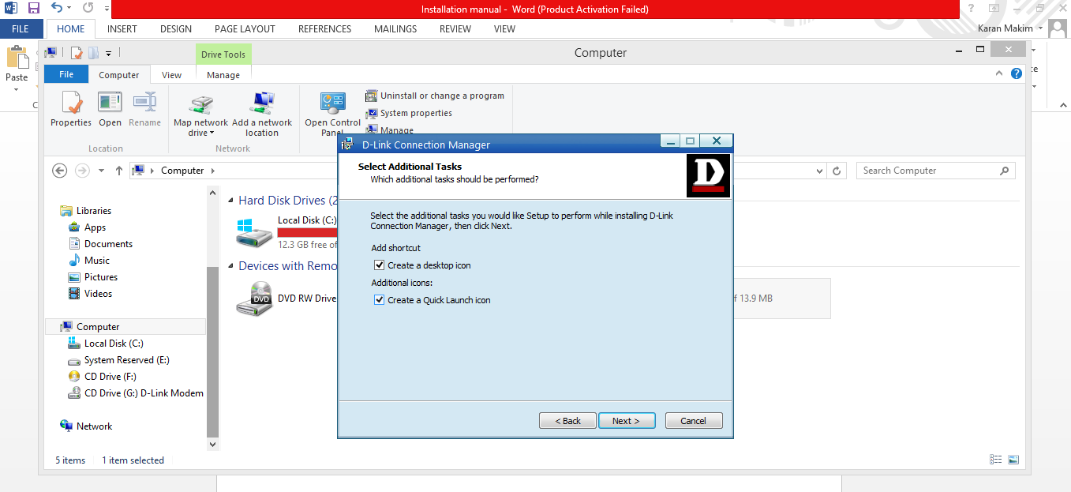

Click ‘Next’ and it’s done.

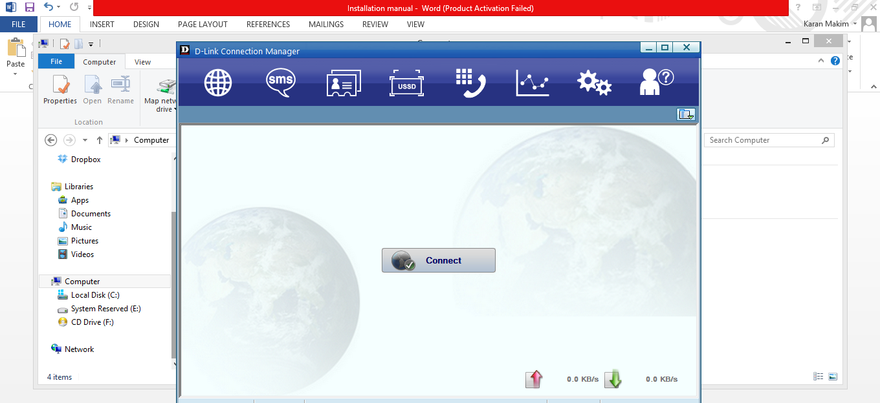

Click ‘Connect’ and you are connected.

**2.5 Setting up codes with appropriate paths**

* Copy the weatherinfo.php from the disk to the www directory of the wamp server you just installed.
* Copy the translator.jar file from the disk to your system and copy the path. This path will be used for connection during configuration.

**3. Configuring the Software**

* 1. **Setup the databases**

Launch phpMyAdmin

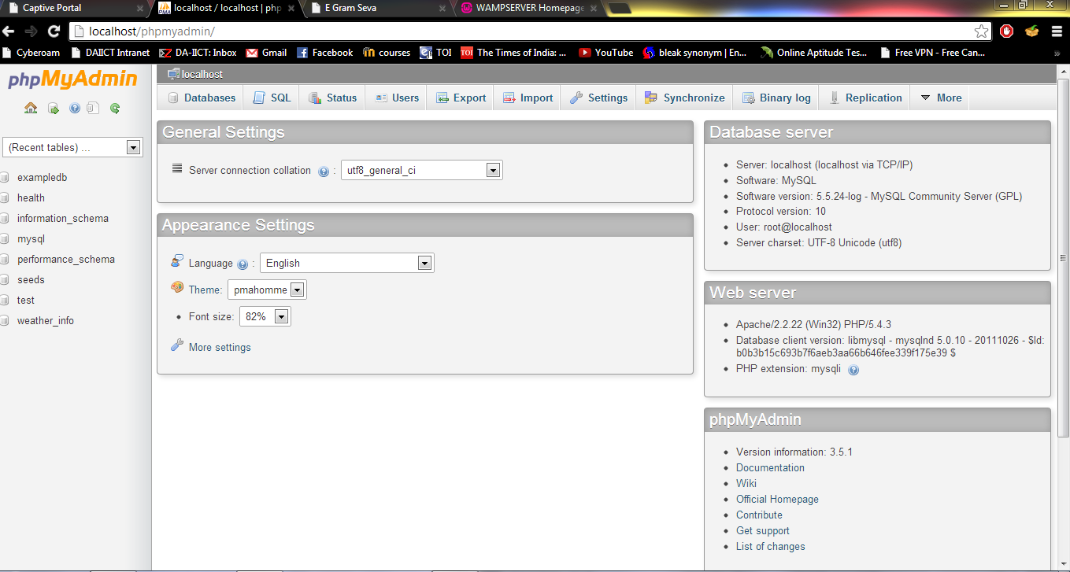

Import the ‘test’ database

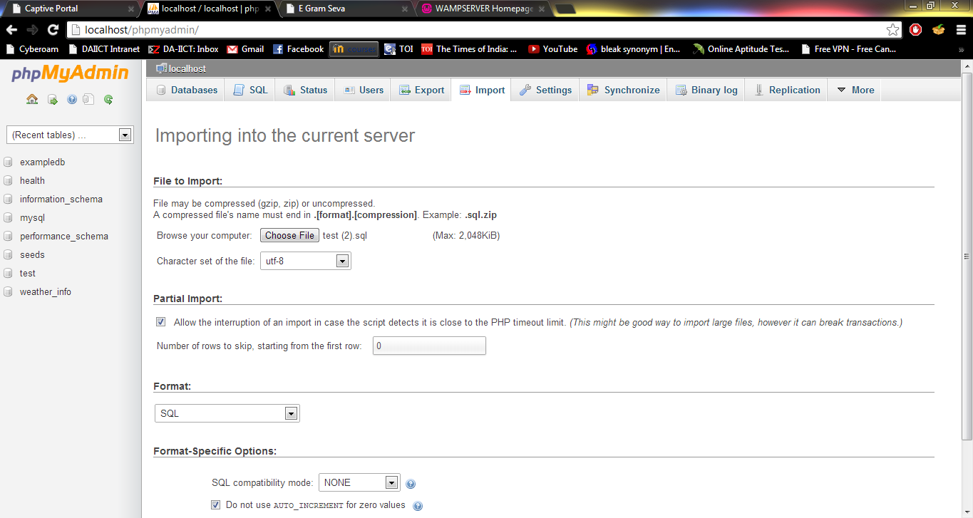

**3.2 Configure Diafaan, connections between database and Diafaan**

Start Diafaan Manager. Add GSM Gateway.

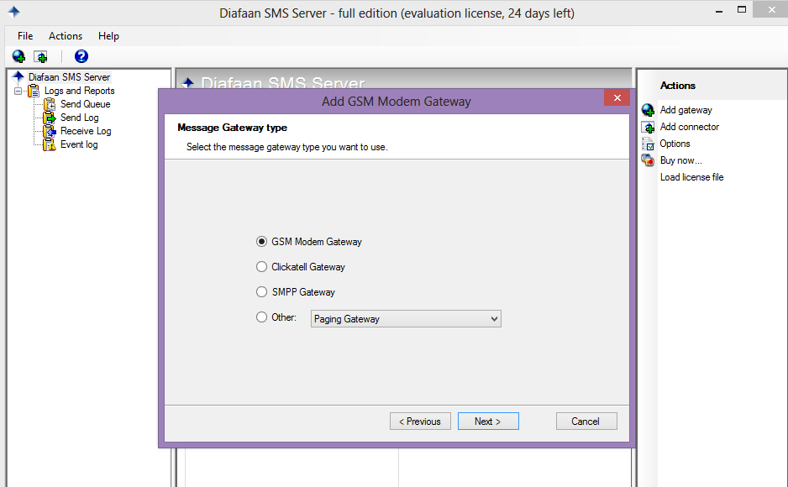

Check for working modem port and test connection

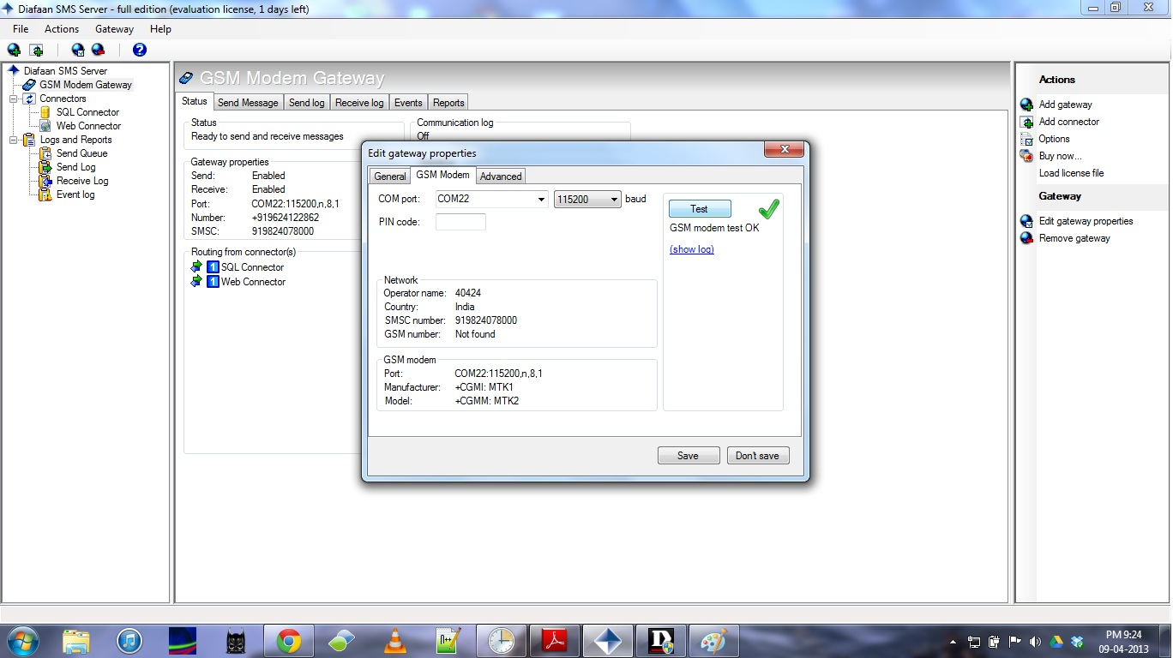

Configure database(SQL) Connector

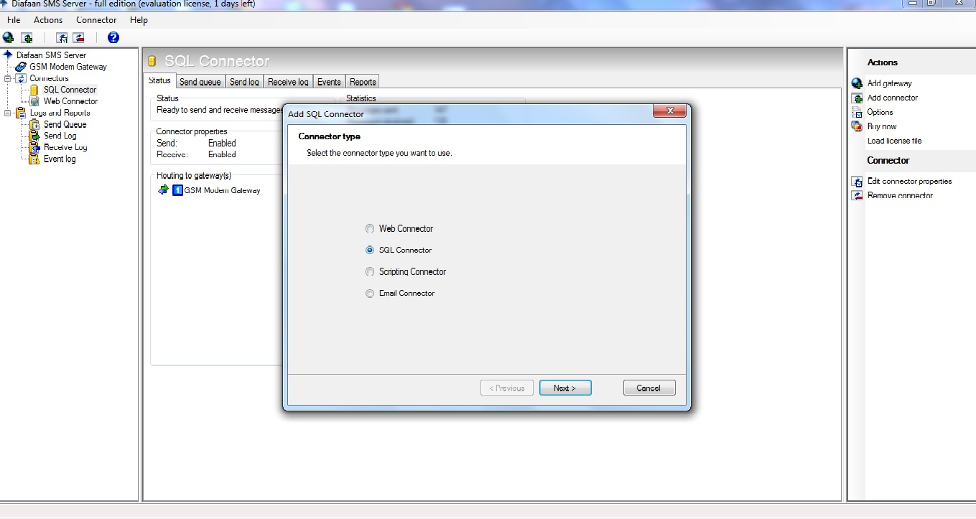

Next Step

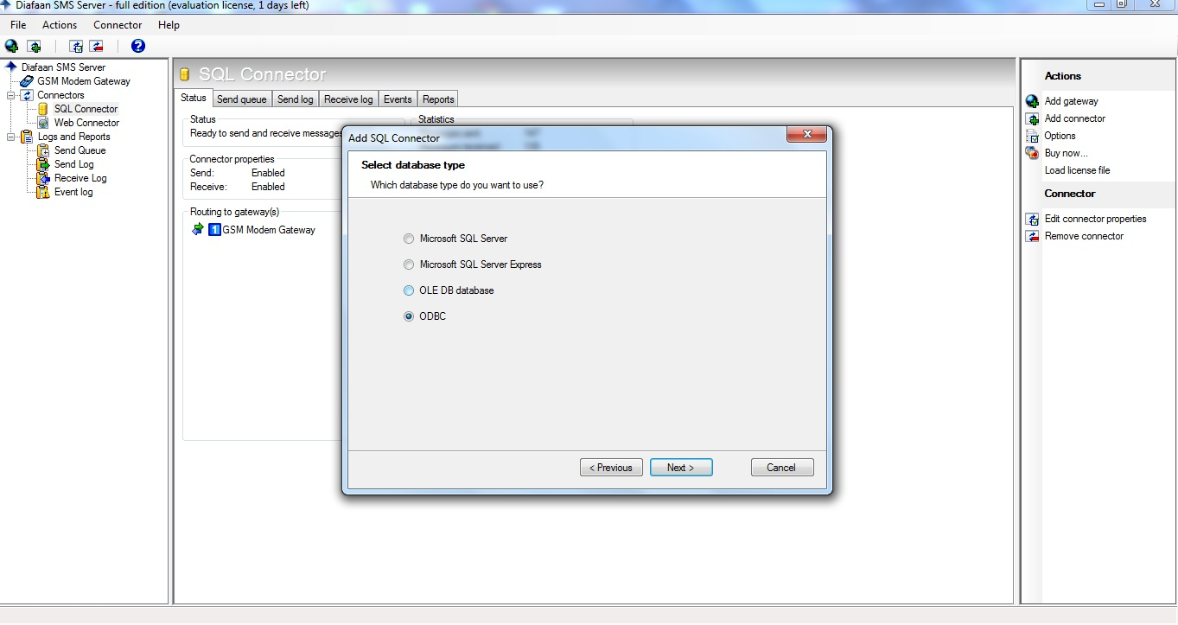

Enter the following connection string for ODBC connector :

Driver={MySQL ODBC 5.1 Driver};

Server= localhost; charset=UTF8; Database=test; User=root; Password=; Option=3;

and test connections

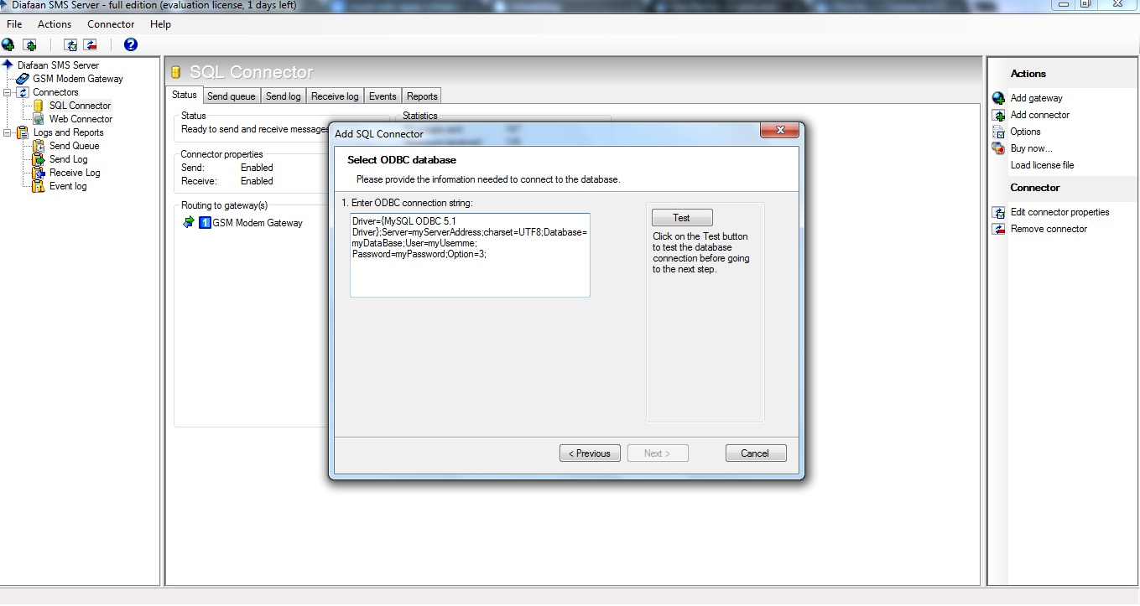

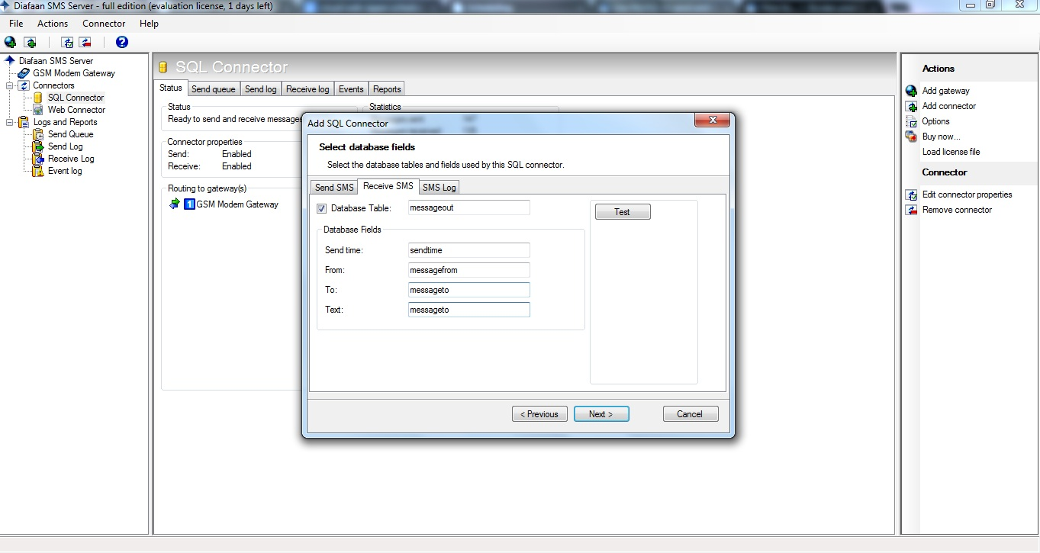

* 1. **Configure Windows Task Scheduler**

Start the Task Scheduler and create a new basic task

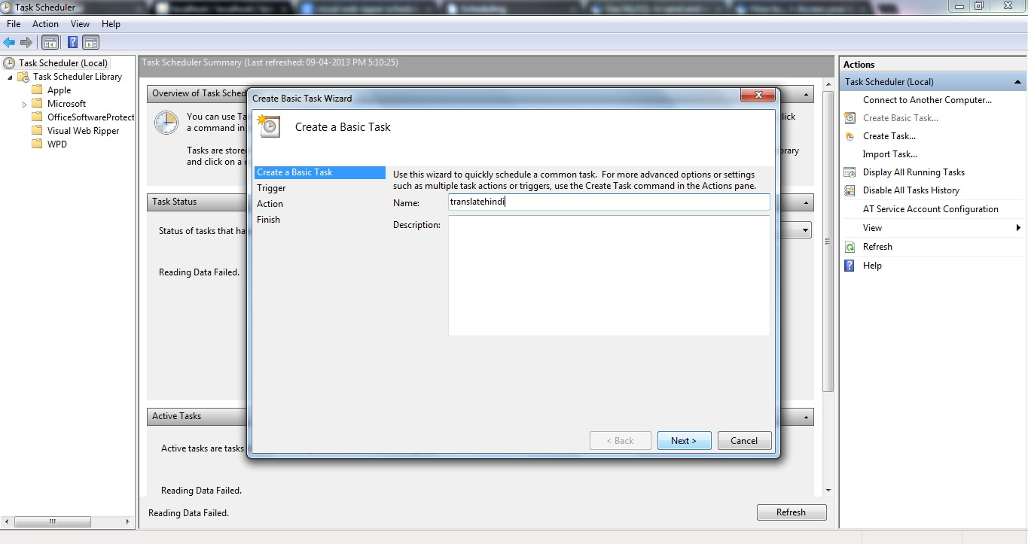

* 1. **Set up time for schedules.**

Set Period

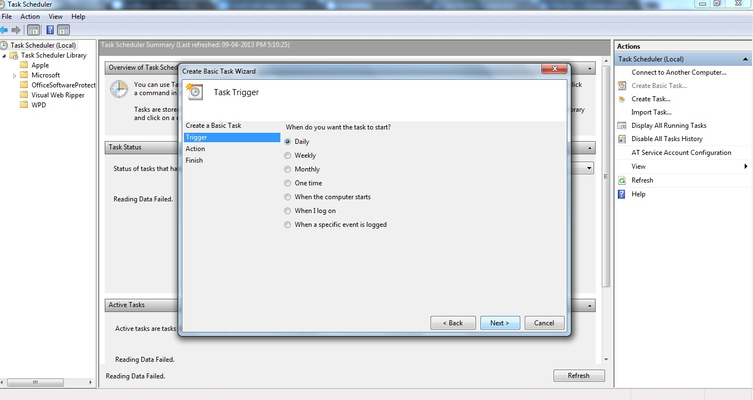

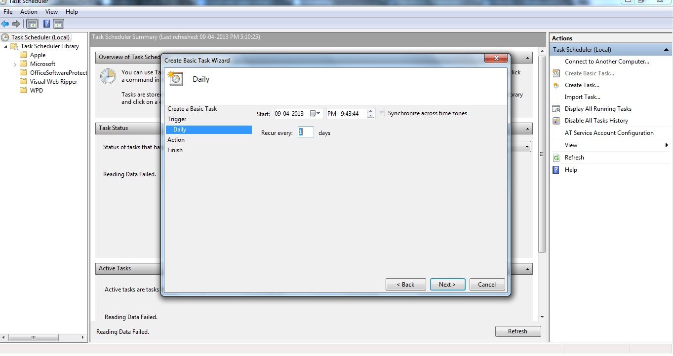

Follow the Steps

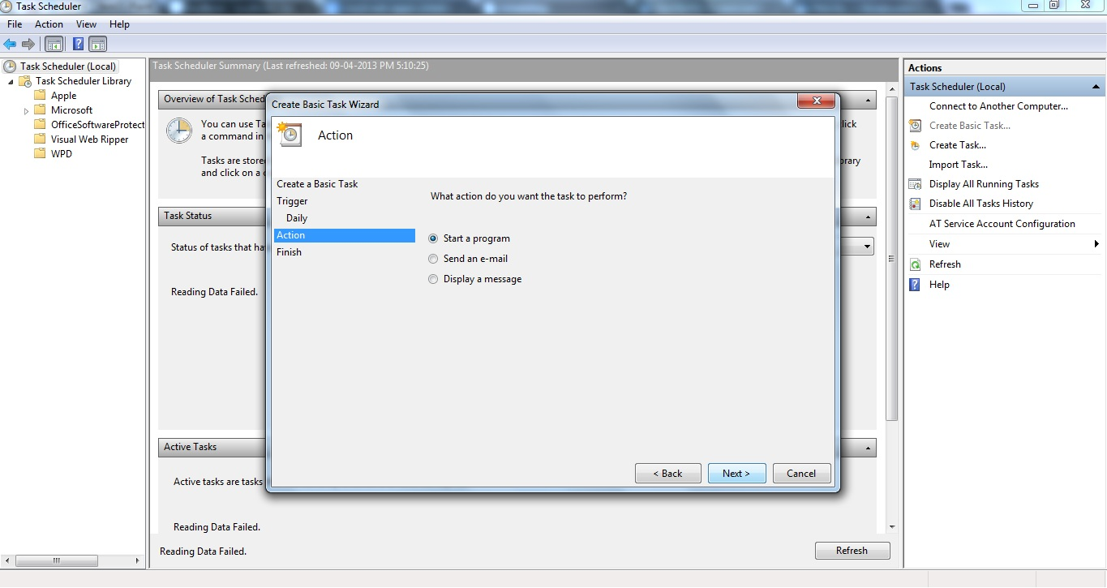

Set paths for java.ex , jar file and platform in the appropriate textboxes

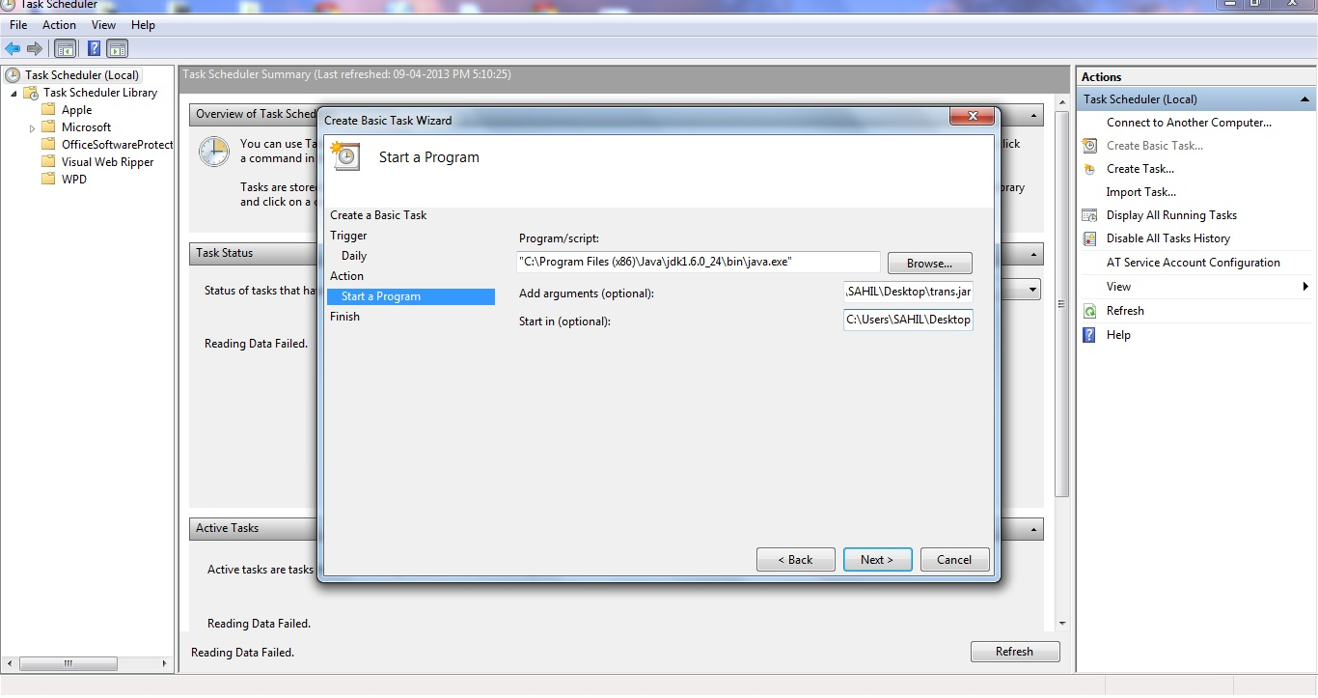

Here , for example , program="C:\Program Files (x86)\Java\jdk1.6.0_24\bin\java.exe"

Argument=-jar C:\Users\SAHIL\Desktop\trans.jar

Start in path C:\Users\SAHIL\Desktop

Give a name to the task

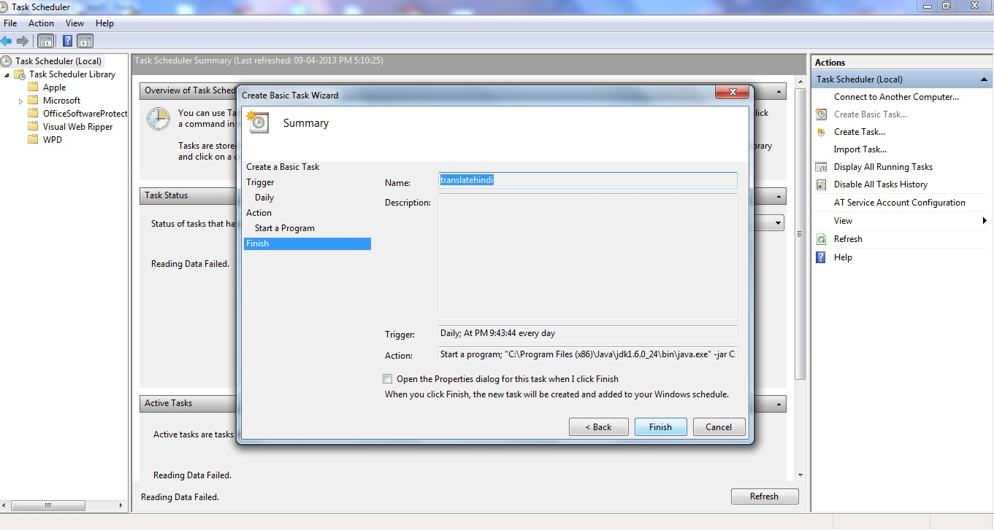

And the task gets scheduled

Repeat the same for “weatherinfo.php”

With following details:

Program=C:\wamp\bin\php\php5.4.3\php-win.exe

Argument=-f C:\wamp\www\weatherInfo.php

Platform=C:\wamp\www

In case of Web Ripper , the Scheduler of the Software itself adds the task to windows task scheduler. So , it needs to be kept running on machine with the setting of scheduler as:

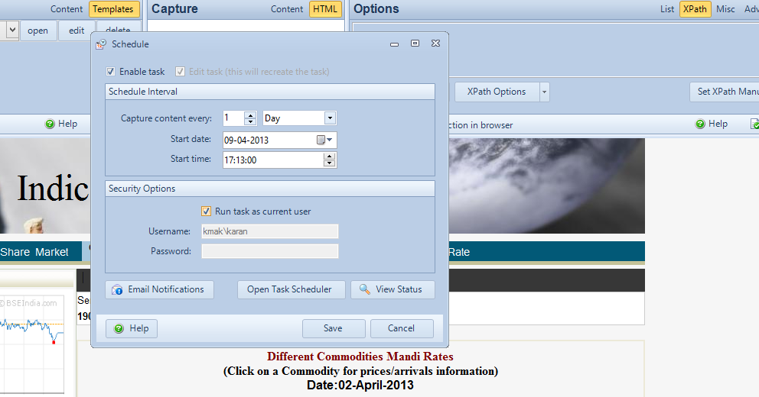

7. Also don’t forget to set the scheduler of wamp server (this is for sending the final sms on a schedule)

Note: This is an event and can be chosen from the topmost taskbar of phpMyAdmin for our database.

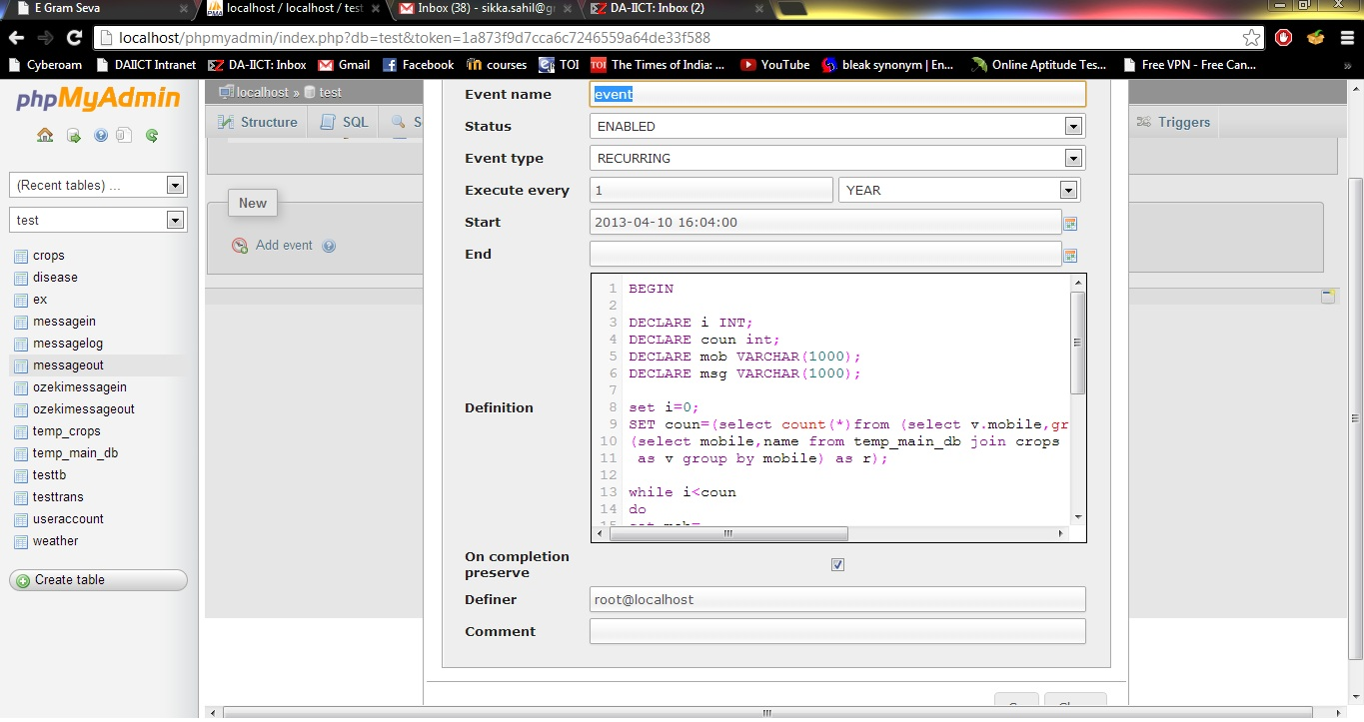

1. **System Requirement**

The Operating System required for this software to be installed on windows XP, windows Vista and windows 7 Disk space requirements:

|  |  |  |
| --- | --- | --- |
| **Program** | **Disk Space required**  **(minimum)** | **RAM required (minimum)** |
| Visual Web Ripper | 24 MB | 128 MB |
| wampp | 276 MB | 128 MB |
| Diafaan | 10 MB | 128 MB |
| E Gram Seva – Yuva Unstoppable (Client) | 45 MB | 128 MB |

|  |  |
| --- | --- |
| 1 | Prof. ASIM BANERJEE |
| 2 | RUTVIK SINGH MAYURDHVAJ JHALA |
| 3 | MAKIM KARAN NARESH |
| 4 | AAYUSHI SHARMA |
| 5 | SAHIL SIKKA |
| 6 | VADNAGARA SIDDHARTH PARESHKUMAR |
| 7 | SURBHI SINGHAL |
| 8 | BIMAN GUJRAL |
| 9 | KRISHNA MAHAJAN |
| 10 | ABHISHEK SHUKLA |

**8. Intended Readers**

* Project Reviewer (Prof. Asim Banerjee)
* Project Designer
* Project Developer
* Project Tester
* Client